St. John’s Lutheran Church
159 Rt 26A, Stuyvesant, NY 12173
Stjohnsstuyvesant.org

Pr. Dan Cohn stjohnsstuyvesant@gmail.com
518-758-1891 (church) St. John’s Lutheran (Facebook)

7th Sunday in Easter Service
May 24, 2020

Easter Greeting
He is Risen
He Has Risen Indeed! Alleluia!
He is Risen
He Has Risen Indeed! Alleluia!
He is Risen
He Has Risen Indeed! Alleluia!

644 The Church’s One Foundation sts. 1–5
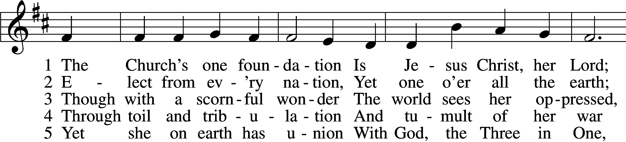
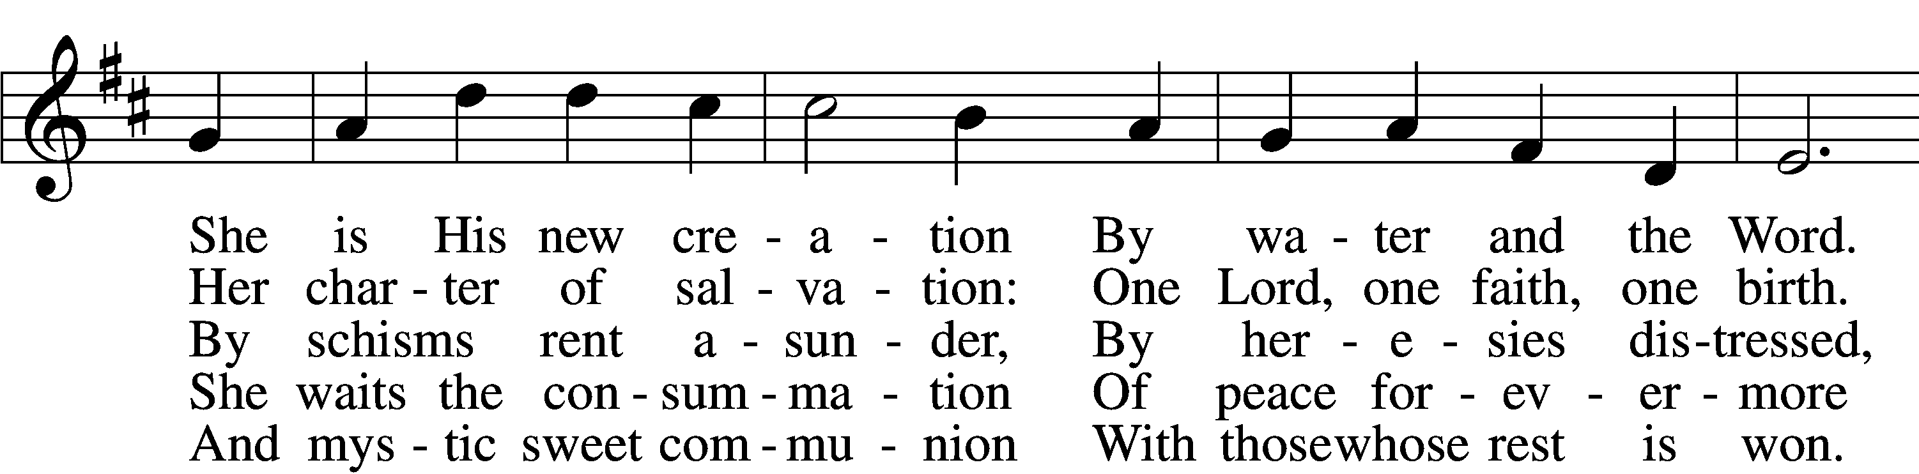
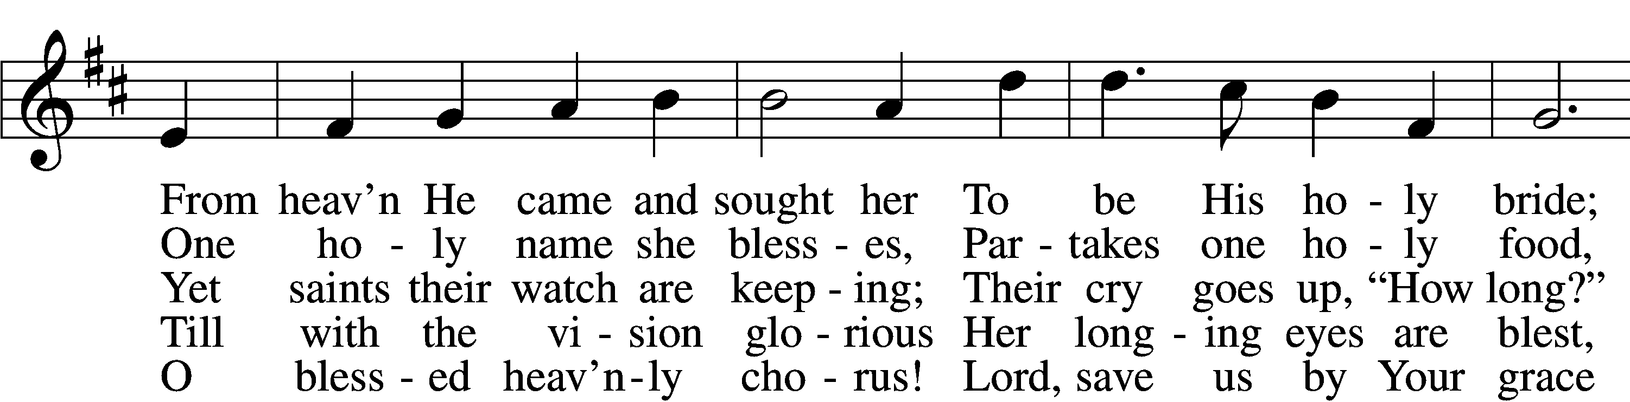
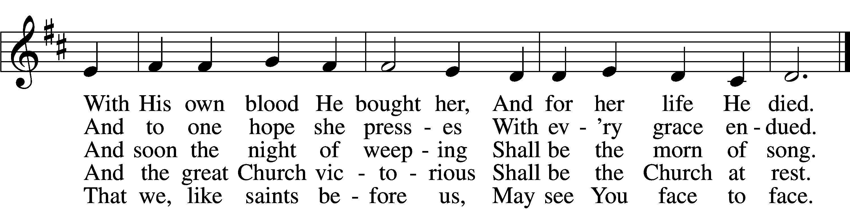
Text and tune: Public domain

The sign of the cross may be made by all in remembrance of their Baptism.

P In the name of the Father and of the T Son and of the Holy Spirit.
C Amen.
P If we say we have no sin, we deceive ourselves, and the truth is not in us.
C But if we confess our sins, God, who is faithful and just, will forgive our sins and cleanse us from all unrighteousness.

Silence for reflection on God’s Word and for self-examination.

P Let us then confess our sins to God our Father.
C Most merciful God, we confess that we are by nature sinful and unclean. We have sinned against You in thought, word, and deed, by what we have done and by what we have left undone. We have not loved You with our whole heart; we have not loved our neighbors as ourselves. We justly deserve Your present and eternal punishment. For the sake of Your Son, Jesus Christ, have mercy on us. Forgive us, renew us, and lead us, so that we may delight in Your will and walk in Your ways to the glory of Your holy name. Amen.

P Almighty God in His mercy has given His Son to die for you and for His sake forgives you all your sins. As a called and ordained servant of Christ, and by His authority, I therefore forgive you all your sins in the name of the Father and of the T Son and of the Holy Spirit.
C Amen.

Service of the Word

Introit Psalm 68:1–10; antiphon: v. 32
1God shall arise, his enemies shall be scattered;
and those who hate him shall flee before him!
2As smoke is driven away, so you shall drive them away;
as wax melts before fire,
so the wicked shall perish before God!
3But the righteous shall be glad;
they shall exult before God;
they shall be jubilant with joy!
4Sing to God, sing praises to his name;
lift up a song to him who rides through the deserts;
his name is the Lord;
exult before him!
5Father of the fatherless and protector of widows
is God in his holy habitation.
6God settles the solitary in a home;
he leads out the prisoners to prosperity,
but the rebellious dwell in a parched land.
7O God, when you went out before your people,
when you marched through the wilderness,
8the earth quaked, the heavens poured down rain,
before God, the One of Sinai,
before God, the God of Israel.
9Rain in abundance, O God, you shed abroad;
you restored your inheritance as it languished;
10your flock found a dwelling in it;
in your goodness, O God, you provided for the needy.

Kyrie LSB 152
A In peace let us pray to the Lord.
C Lord, have mercy.
A For the peace from above and for our salvation let us pray to the Lord.
C Lord, have mercy.
A For the peace of the whole world, for the well-being of the Church of God, and for the unity of all let us pray to the Lord.
C Lord, have mercy.
A For this holy house and for all who offer here their worship and praise let us pray to the Lord.
C Lord, have mercy.
A Help, save, comfort, and defend us, gracious Lord.
C Amen.

This Is the Feast LSB 155
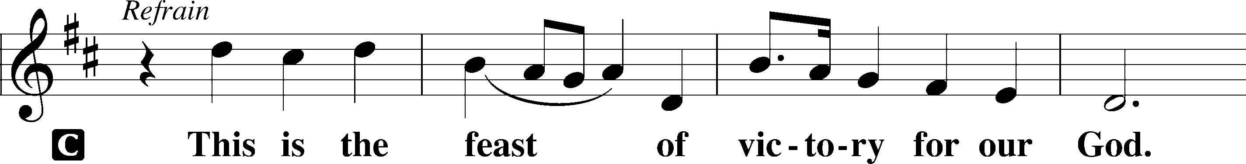
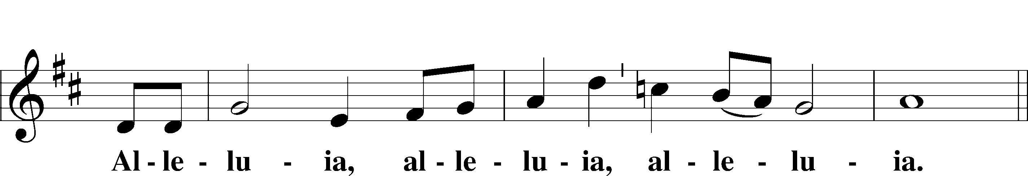
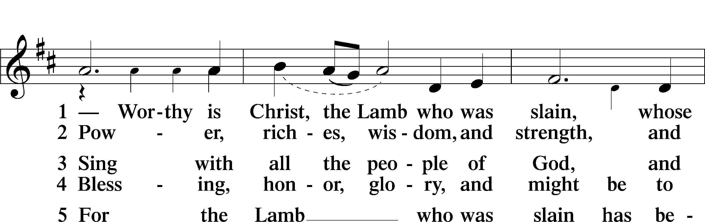
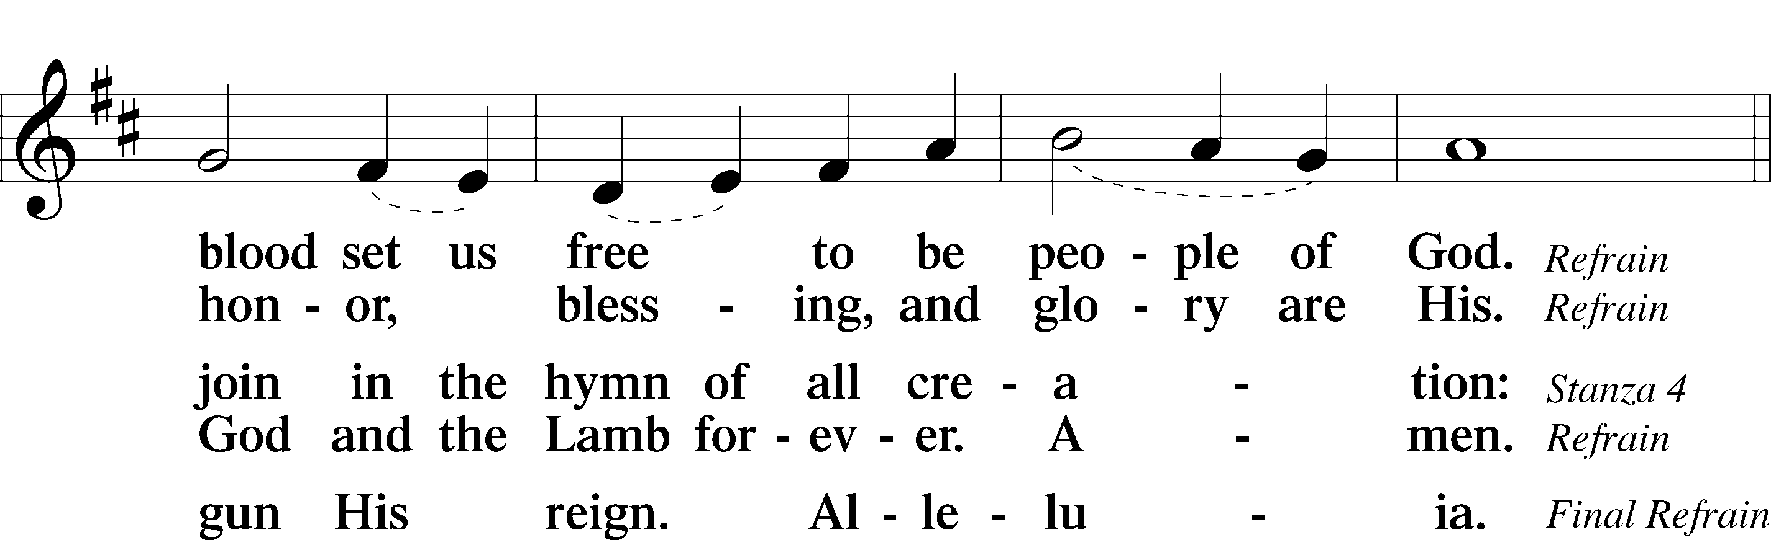
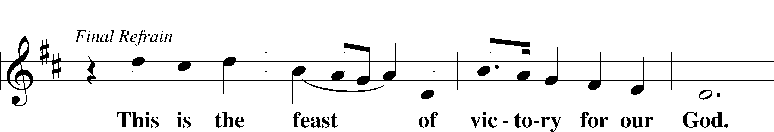
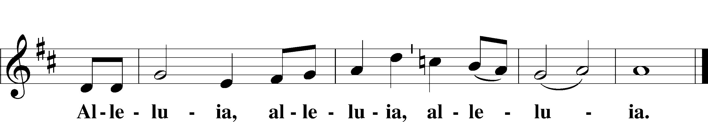

Salutation and Collect of the Day
P The Lord be with you.
C And also with you.
P Let us pray.
O King of glory, Lord of hosts, uplifted in triumph far above all heavens, leave us not without consolation but send us the Spirit of truth whom You promised from the Father; for You live and reign with Him and the Holy Spirit, one God, now and forever.
C Amen.

First Reading Acts 1:12–26
12Then [the apostles] returned to Jerusalem from the mount called Olivet, which is near Jerusalem, a Sabbath day’s journey away. 13And when they had entered, they went up to the upper room, where they were staying, Peter and John and James and Andrew, Philip and Thomas, Bartholomew and Matthew, James the son of Alphaeus and Simon the Zealot and Judas the son of James. 14All these with one accord were devoting themselves to prayer, together with the women and Mary the mother of Jesus, and his brothers.
15In those days Peter stood up among the brothers (the company of persons was in all about 120) and said, 16“Brothers, the Scripture had to be fulfilled, which the Holy Spirit spoke beforehand by the mouth of David concerning Judas, who became a guide to those who arrested Jesus. 17For he was numbered among us and was allotted his share in this ministry.” 18(Now this man bought a field with the reward of his wickedness, and falling headlong he burst open in the middle and all his bowels gushed out. 19And it became known to all the inhabitants of Jerusalem, so that the field was called in their own language Akeldama, that is, Field of Blood.) 20“For it is written in the Book of Psalms,
“‘May his camp become desolate,
and let there be no one to dwell in it’;
and
“‘Let another take his office.’
21So one of the men who have accompanied us during all the time that the Lord Jesus went in and out among us, 22beginning from the baptism of John until the day when he was taken up from us—one of these men must become with us a witness to his resurrection.” 23And they put forward two, Joseph called Barsabbas, who was also called Justus, and Matthias. 24And they prayed and said, “You, Lord, who know the hearts of all, show which one of these two you have chosen 25to take the place in this ministry and apostleship from which Judas turned aside to go to his own place.” 26And they cast lots for them, and the lot fell on Matthias, and he was numbered with the eleven apostles.

A This is the Word of the Lord.
C Thanks be to God.

Psalm adapt. from Matthew 28:7; Hebrews 2:7; Psalm 8:6
Christ has risen from the dead.
[God the Father] has crowned him with glory and honor.
He has given him dominion over the works of his hands;
he has put all things under his feet.

Epistle 1 Peter 4:12–19; 5:6–11
12Beloved, do not be surprised at the fiery trial when it comes upon you to test you, as though something strange were happening to you. 13But rejoice insofar as you share Christ’s sufferings, that you may also rejoice and be glad when his glory is revealed. 14If you are insulted for the name of Christ, you are blessed, because the Spirit of glory and of God rests upon you. 15But let none of you suffer as a murderer or a thief or an evildoer or as a meddler. 16Yet if anyone suffers as a Christian, let him not be ashamed, but let him glorify God in that name. 17For it is time for judgment to begin at the household of God; and if it begins with us, what will be the outcome for those who do not obey the gospel of God? 18And
“If the righteous is scarcely saved,
what will become of the ungodly and the sinner?”
19Therefore let those who suffer according to God’s will entrust their souls to a faithful Creator while doing good. . . .
6Humble yourselves, therefore, under the mighty hand of God so that at the proper time he may exalt you, 7casting all your anxieties on him, because he cares for you. 8Be sober-minded; be watchful. Your adversary the devil prowls around like a roaring lion, seeking someone to devour. 9Resist him, firm in your faith, knowing that the same kinds of suffering are being experienced by your brotherhood throughout the world. 10And after you have suffered a little while, the God of all grace, who has called you to his eternal glory in Christ, will himself restore, confirm, strengthen, and establish you. 11To him be the dominion forever and ever. Amen.

A This is the Word of the Lord.
C Thanks be to God.

Alleluia and Verse LSB 156
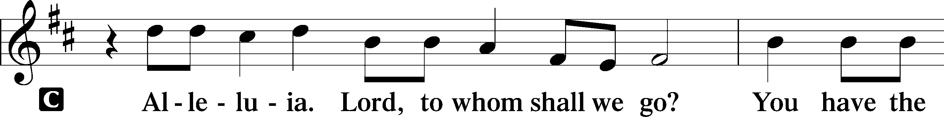
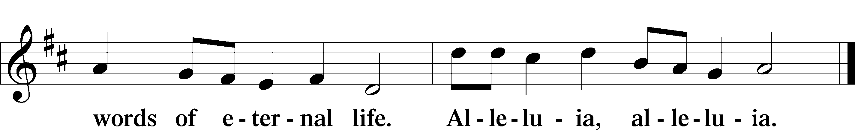

Holy Gospel John 17:1–11
P The Holy Gospel according to St. John, the seventeenth chapter.
C Glory to You, O Lord.
1When Jesus had spoken these words, he lifted up his eyes to heaven, and said, “Father, the hour has come; glorify your Son that the Son may glorify you, 2since you have given him authority over all flesh, to give eternal life to all whom you have given him. 3And this is eternal life, that they know you the only true God, and Jesus Christ whom you have sent. 4I glorified you on earth, having accomplished the work that you gave me to do. 5And now, Father, glorify me in your own presence with the glory that I had with you before the world existed.
6“I have manifested your name to the people whom you gave me out of the world. Yours they were, and you gave them to me, and they have kept your word. 7Now they know that everything that you have given me is from you. 8For I have given them the words that you gave me, and they have received them and have come to know in truth that I came from you; and they have believed that you sent me. 9I am praying for them. I am not praying for the world but for those whom you have given me, for they are yours. 10All mine are yours, and yours are mine, and I am glorified in them. 11And I am no longer in the world, but they are in the world, and I am coming to you. Holy Father, keep them in your name, which you have given me, that they may be one, even as we are one.”

P This is the Gospel of the Lord.
C Praise to You, O Christ.

662 Onward, Christian Soldiers
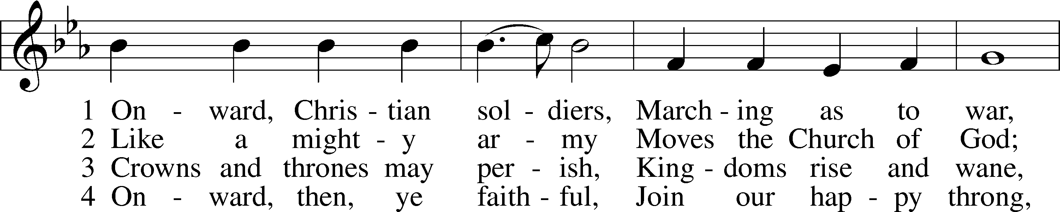
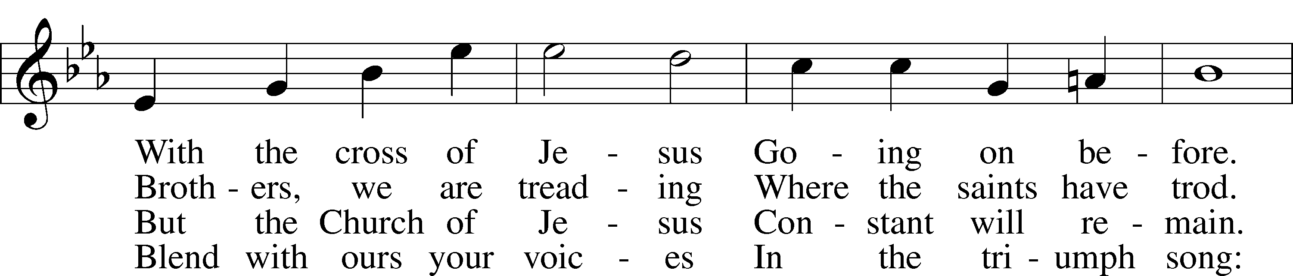
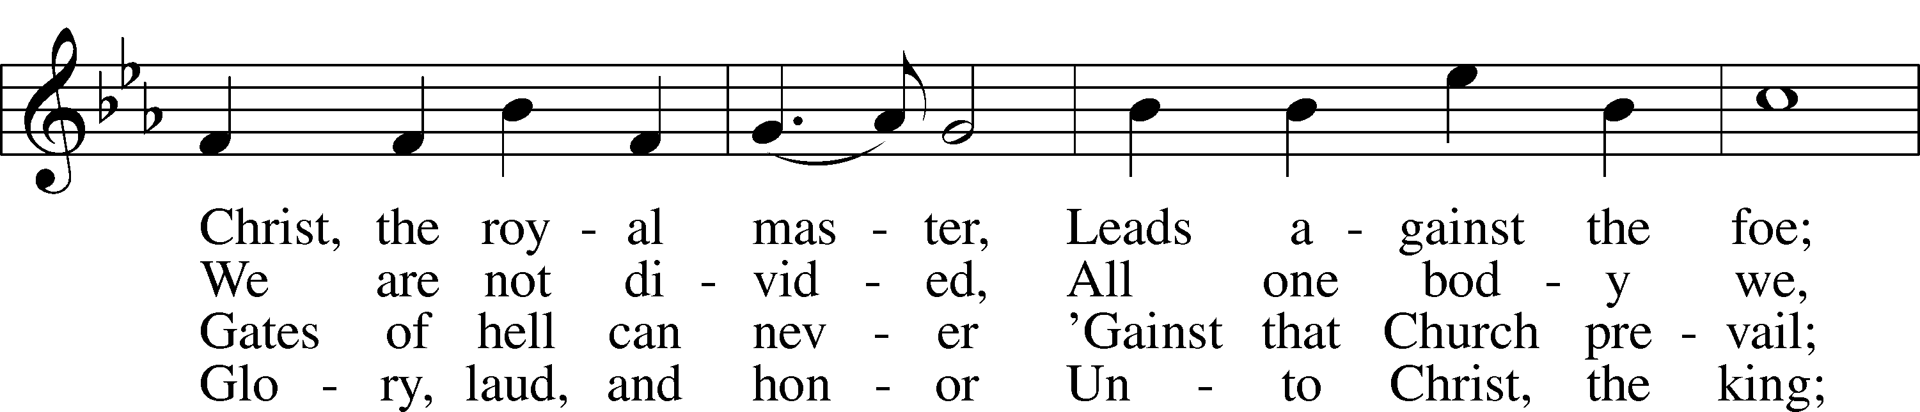
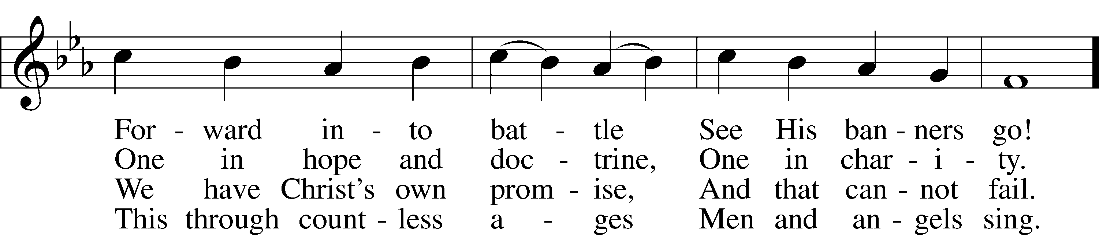
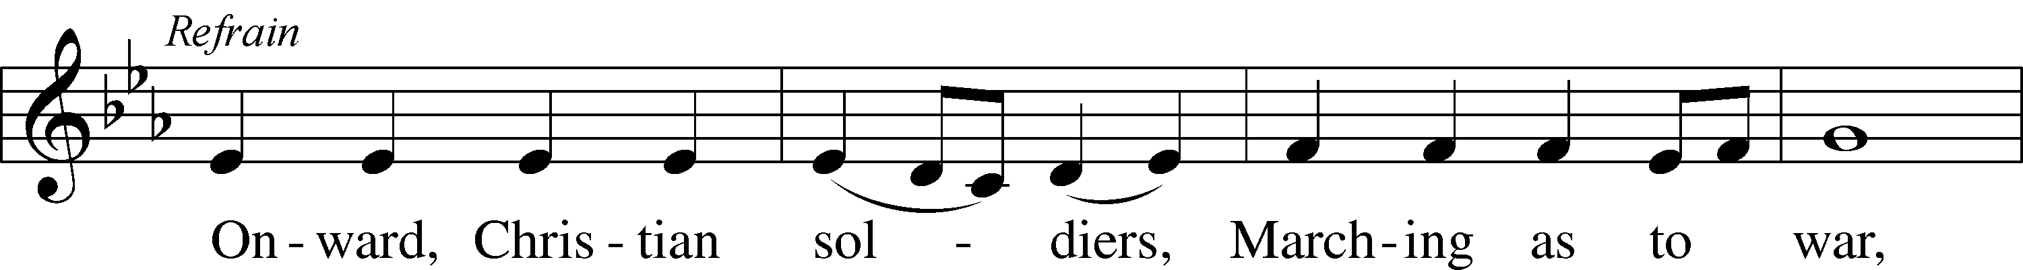
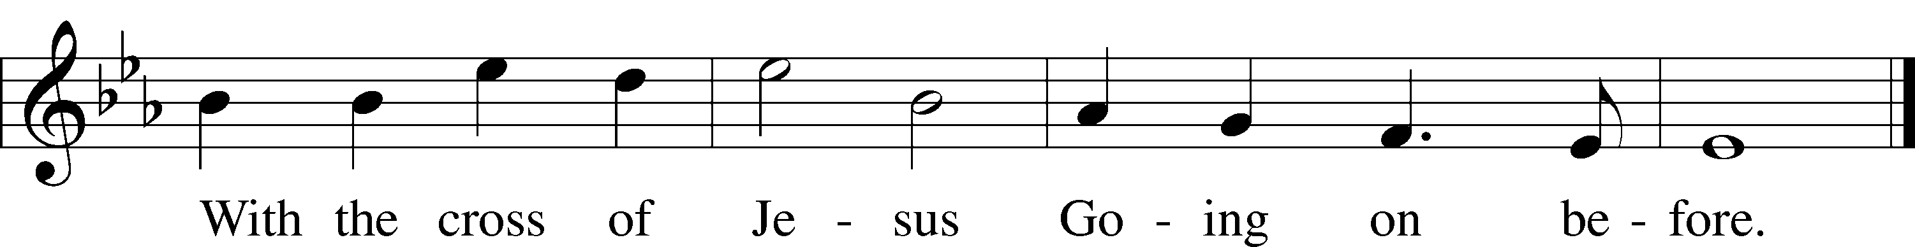
Text and tune: Public domain
Sermon

Apostles’ Creed
C I believe in God, the Father Almighty,
maker of heaven and earth.

And in Jesus Christ, His only Son, our Lord,
who was conceived by the Holy Spirit,
born of the virgin Mary,
suffered under Pontius Pilate,
was crucified, died and was buried.
He descended into hell.
The third day He rose again from the dead.
He ascended into heaven
and sits at the right hand of God the Father Almighty.
From thence He will come to judge the living and the dead.

I believe in the Holy Spirit,
the holy Christian Church,
the communion of saints,
the forgiveness of sins,
the resurrection of the body,
and the life T everlasting. Amen.

Prayer of the Church

Following the prayers, the people may greet one another in the name of the Lord, saying, “Peace be with you,” as a sign of reconciliation and of the unity of the Spirit in the bond of peace (Matt. 5:22–24; Eph. 4:1–3).

Offering

Offertory LSB 159
C What shall I render to the Lord for all His benefits to me?
I will offer the sacrifice of thanksgiving and will call on the name of the Lord.
I will take the cup of salvation and will call on the name of the Lord.
I will pay my vows to the Lord now in the presence of all His people,
in the courts of the Lord’s house, in the midst of you, O Jerusalem.

781 We Give Thee But Thine Own sts. 1–2
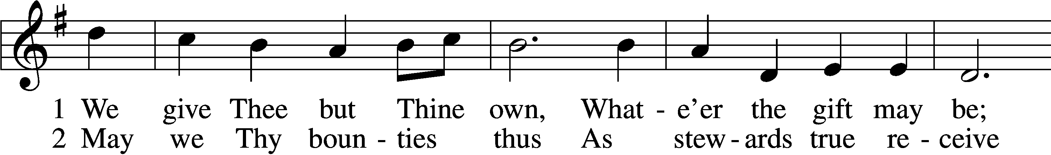
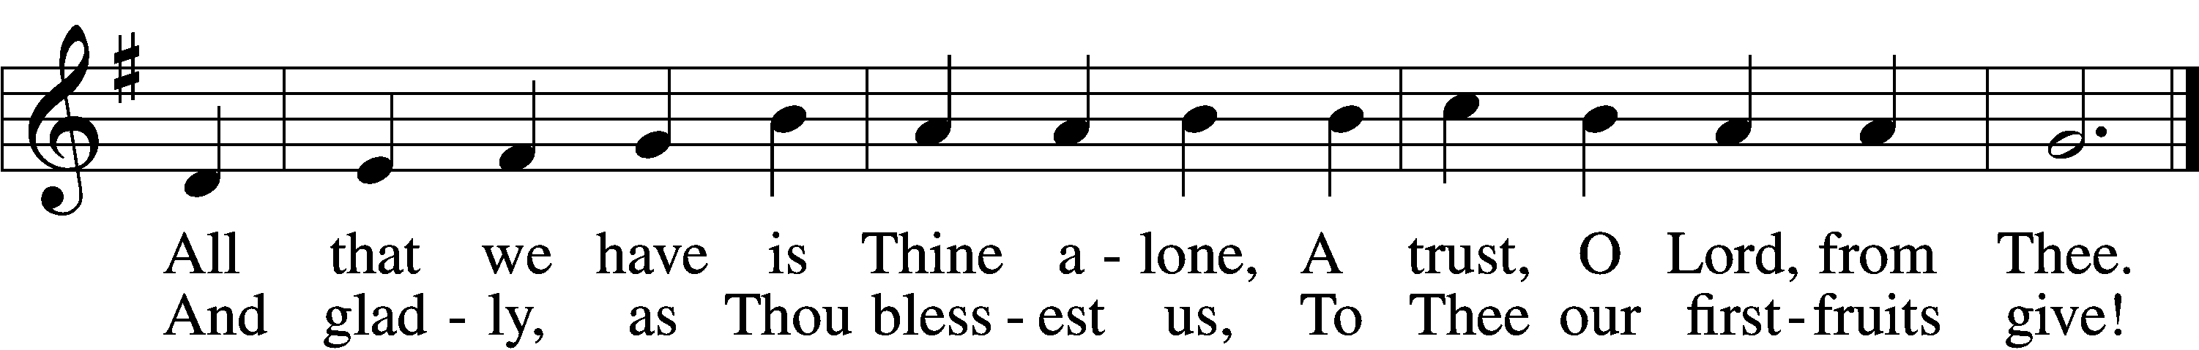
Tune and text: Public domain

Lord’s Prayer
C Our Father who art in heaven,
hallowed be Thy name,
Thy kingdom come,
Thy will be done on earth
as it is in heaven;
give us this day our daily bread;
and forgive us our trespasses
as we forgive those
who trespass against us;
and lead us not into temptation,
but deliver us from evil.
For Thine is the kingdom
and the power and the glory
forever and ever. Amen.

Benediction LSB 166
P The Lord bless you and keep you.
The Lord make His face shine on you and be gracious to you.
The Lord look upon you with favor and T give you peace.
C Amen.

924 Lord, Dismiss Us with Your Blessing
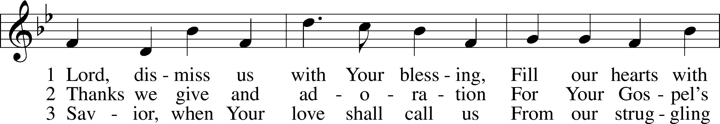
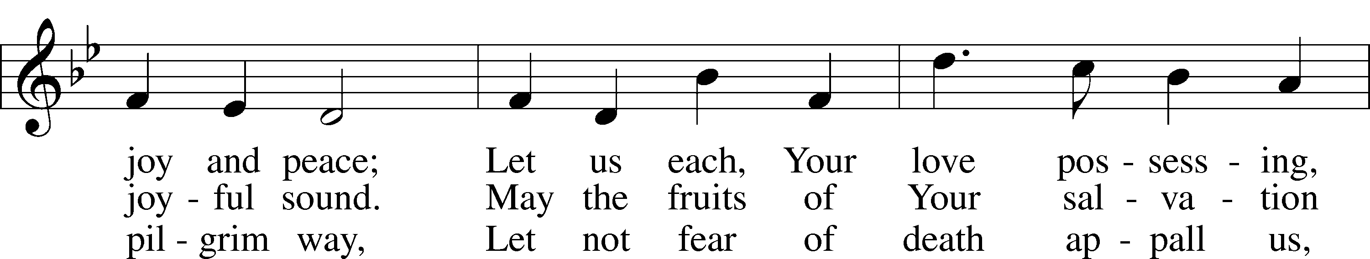
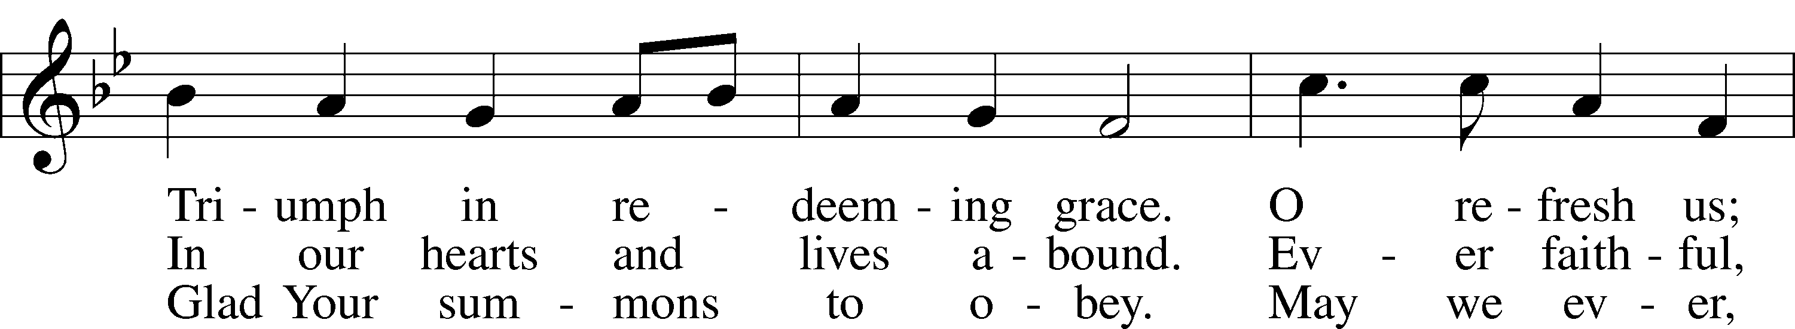
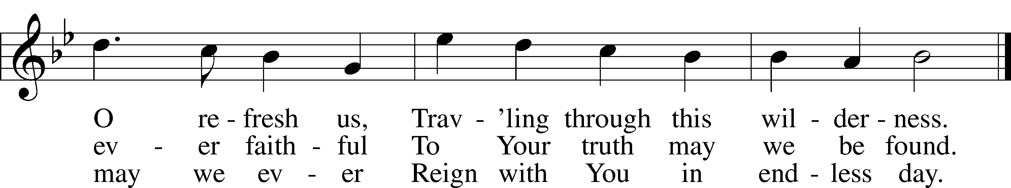
Text and tune: Public domain

Acknowledgments
Divine Service, Setting One from Lutheran Service Book
Unless otherwise indicated, Scripture quotations are from the ESV® Bible (The Holy Bible, English Standard Version®), copyright © 2001 by Crossway, a publishing ministry of Good News Publishers. Used by permission. All rights reserved.
Created by Lutheran Service Builder © 2018 Concordia Publishing House.

